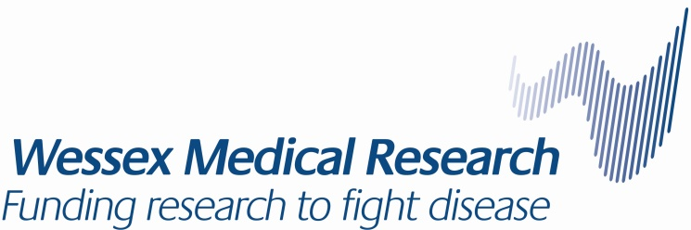

WESSEX MEDICAL TRUST (“WMT”)

SCIENTIFIC/PEER REVIEW OF GRANT APPLICATIONS

There is a two tier system for reviews:
- GRANTS OF UP TO £50,000
(this would typically include all grants from the Innovation Fund, which are currently valued at £20,000 each)
- All applications are initially reviewed and anonymised by the Chair of the Scientific Advisory Committee (the “Committee”) who then allocates each application for detailed review to at least three members of the Committee depending on their areas of expertise. No Committee member is permitted to apply to WMT for a grant during their period of office.

- Following review, the applications are ranked and then discussed by the full Committee with Committee members indicating if they wish the score to be adjusted up or down by 1. Following this peer review, scores are adjusted by the average adjustment across all members and applications are re-ranked. Committee members with conflicts of interest are invited to declare these at the beginning of the meeting and leave the room when the relevant applications are discussed. After this meeting, the preferred application(s) is/are co-ordinated by the Chair and passed to WMT.

- The Committee is comprised of:
Professor John Holloway Associate Dean for Research, Faculty of Medicine,
Chair University of Southampton.
Dr Nisreen Alwan Faculty of Medicine, University of Southampton
Dr Jeremy Blaydes Faculty of Medicine, University of Southampton
Dr Claire Clarkin Faculty of Environmental and Life Sciences.
University of Southampton
Dr Nick Evans Faculty of Medicine, University of Southampton
Dr Jana Kreppner Faculty of Environmental and Life Sciences,
University of Southampton
Professor Deborah Mackay Faculty of Medicine, University of Southampton
Professor Peter L Roach Faculty of Physical Sciences and Engineering,
University of Southampton
Professor Tiina Roose Faculty of Physical Sciences and Engineering,
University of Southampton
Dr Tilman Sanchez-Elsner Faculty of Medicine, University of Southampton
Professor Jon Strefford Faculty of Medicine, University of Southampton
Dr Will Tapper Faculty of Medicine, University of Southampton
Professor Jessica Teeling Faculty of Environmental and Life Sciences’
University of Southampton
Dr Dawn-Marie Walker Faculty of Environmental and Life Sciences,
University of Southampton

- In addition, the Trustees appoint three expert Assessors (the “Assessors”) who are external to the University of Southampton. The current Assessors are:

Professor Hilary Critchley University of Edinburgh
Professor Neil Hanley University of Manchester
Dr Dario Carugo University College London

- One third of the members of the Committee (other than the Chair) together with one of the Assessors are rotated at least every three years. Nobody is normally permitted to hold office for more than six years.
- If any member of the Committee feels unqualified to judge a particular application, he/she is asked to seek advice from a colleague who possesses the relevant expertise.
- All members of the Committee are required to have undertaken training in accordance with the University of Southampton’s Equality and Diversity Policy.
- Following ranking based on the review by members of the Committee, an overall initial ranking schedule is then co-ordinated by the Chair and passed to WMT.
- WMT passes the schedule of co-ordinated rankings, together with copies of all the original applications, to the three Assessors who are asked to certify that the ranking is appropriate with regard to both scientific quality and suitability to the published research priorities of the University of Southampton. The Assessors have the authority to adjust the initial ranking following this external review.
- At least one of the Assessors will be invited to meet with the Trustee Board each year.
- Based on the advice received through this process the WMT Trustees make a final decision on the award of (a) grant(s).

- GRANTS OF £50,000 AND OVER

- All applications are initially reviewed and anonymised by the Chair of the Scientific Advisory Committee who then allocates each application for detailed review to at least two members of the Committee depending on their areas of expertise. No Committee member is permitted to apply to WMT for a grant during their period of office
- Following review, the applications are ranked and then discussed by the full Committee with Committee members indicating if they wish the score to be adjusted up or down by 1. Following this peer review, scores are adjusted by the average adjustment across all members and applications are re-ranked. Committee members with conflicts of interest are invited to declare these at the beginning of the meeting and leave the room when the relevant applications are discussed. After this meeting, the preferred application(s) is/are co-ordinated by the Chair and passed to WMT.
- The preferred application(s) is/are sent by WMT for external peer review by at least two independent experts.
- The results of the peer review process are considered by the Chairman who recommends (a) preferred application(s) to WMT.
- WMT passes the schedule of co-ordinated rankings, together with copies of the original applications and two external reviews for each of the preferred application(s), to the three Assessors who are asked to certify that the ranking is appropriate with regard to both scientific quality and suitability to the published research priorities of the University of Southampton. The Assessors have the authority to adjust the initial ranking following this external review.
- Based on advice received through this process the WMT Trustees make a final decision on the award of (a) grant(s).

